Beomjin Han
CSC 142
Homework 6

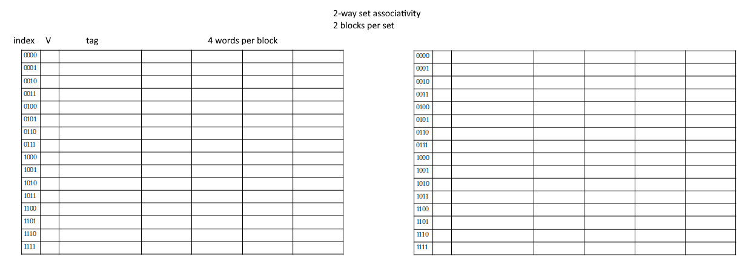
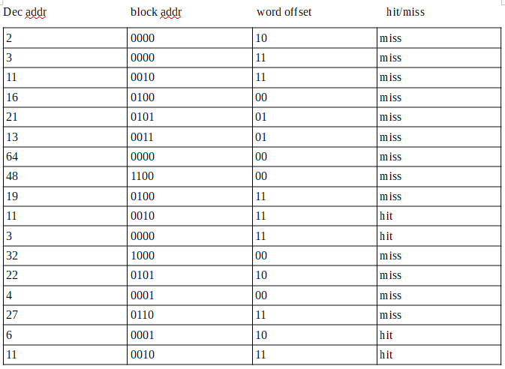
- index – 16 sets – 4 bits
word offset – 4 words per block – 2 bits
byte offset – 1 byte per word – 0 bits

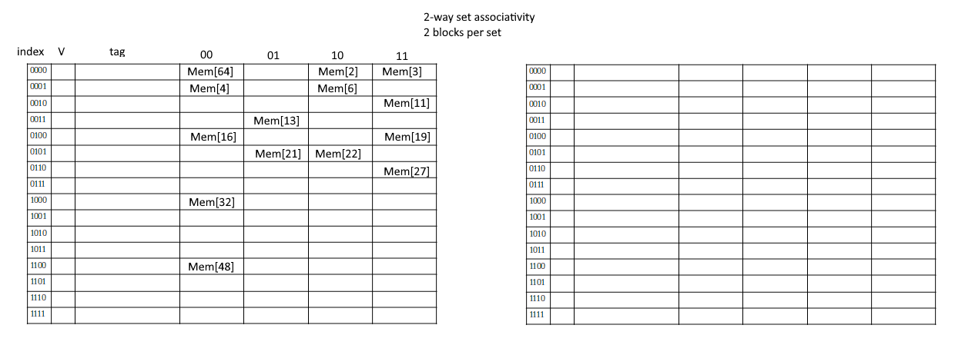
- One set in a fully-associative cache.
- One block per set in a direct-mapped cache.
- 4-way set associative is 4 blocks per set.
- 5.6.1 P1 – 1 / 0.66*10^-9 = 1.5 GHz
P2 – 1 / 0.9*10^-9 = 1.11 GHz
5.6.2 P1 – 0.66ns + 0.08 * 70ns = 6.26ns
P2 – 0.90ns + 0.06 * 70ns = 5.1 ns
5.6.3

